Safe3D Project Proposal

By Luigi Caprio & Jeremy Dorr

SENG 691A

1. **Project Description**

The Safe3D project is a system designed to both autonomously and semi-autonomously monitor the operation of a 3D printer to prevent fires. The system is comprised of a Raspberry Pi single board computer, a solid state relay (SSR), a video camera, a smoke detection circuit, and a temperature sensor. The objective of this product is to detect an event that is causing the printer to operate unsafely and shut it down before things get out of control.

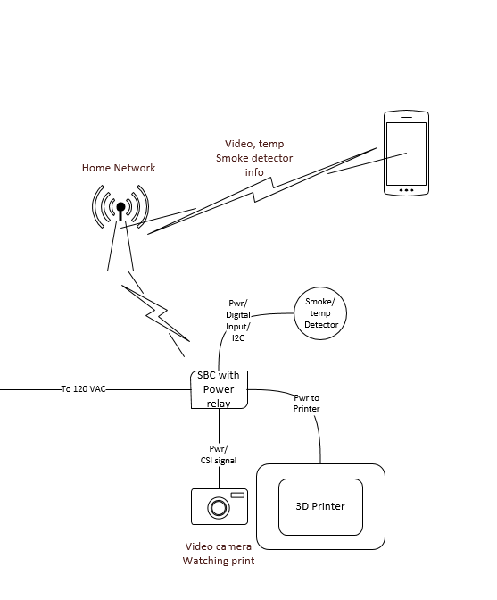

1. **Why this project needs to be developed**

3D printers are an awesome example of what brilliant makers can do when they get together, share information, and set out to make something great. The technology has a great community of engineers, students, makers, and artists who to advance the technology as something that is open source that anyone can build. While this is indeed wonderful, it also creates some dangers when working with a product that is designed to operate at temperatures in excess of 200 degrees Celsius. Bad wiring connections, poor quality power supplies, poorly fixed thermistors, and broken cables all lead to our beloved hobby creating all-to-real fire hazards in our homes. The idea behind the Safe3D system is to allow an almost completely decoupled (the only coupled point is the AC power going in to the printer) system to monitor the 3D printer as it works, and if something unsafe is detect to shut it down immediately.

1. **Possible Markets or Users**

To gain the support of the maker community this product would be best suited as an open source product. The plans and firmware would be readily available free of charge to anyone, while complete systems would also be available for purchase. This product could also be marketed to companies who use 3D printers, and we can offer support and custom software to these companies to generate revenue. The end goal of this project should not be to generate revenue, but to foster the maker movement that has led to advances such as 3D printing while making it safer for household use.

1. **Hardware Technology Description**

There will be several components and technologies utilized in this project. Each will be described in the following sections.

**4.1 Raspberry Pi Single Board Computer**

The Raspberry Pi 2 Model B SBC will be used to read the sensors and camera input, it will also be used to toggle the SSR. The Raspberry Pi is a fully capable Linux computer that has 1GB of ram and a quad-core ARM Cortx-A7 CPU running at 900 MHz We will be utilizing several of the available GPIO pins, as well as the CSI camera interface on the Pi.

**4.2 Raspberry Pi Camera Board**

The camera this project will utilize is a Raspberry Pi camera board designed to use the Camera Serial Interface (CSI) bus. The CSI bus is specifically designed to carry pixel data and can send data at very high rates.

**4.3 Solid State Relay**

A solid state relay will be used to enable the Raspberry Pi to turn off the power to the printer. The relay will need to be capable of switching 120VAC at 20 Amps. Care must be taken to choose a relay that can be switched by the 3.3V 8ma output of the Raspberry Pi’s GPIO pins.

**4.4 Smoke Detection Circuit**

For the purpose of prototyping the first few units a cheap smoke detector can be purchased from a retail store. It should be relatively simple to find a place to tap out a little voltage that switches on and off when the alarm is triggered.

**4.5 Temperature Sensor**

A temperature sensor will be used to detect unsafe temperatures around the printer. The sensor of choice is the TMP102 digital temperature sensor. This sensor was chosen because it utilizes the I2C bus to communicate with the Raspberry Pi saving the need for an analog to digital circuit since the Pi does not have any analog inputs. The TMP102 also features 12-bit .0625 degree resolution and .5 degree Celsius accuracy. The sensing range is -25C to +85C which should be high enough for our purposes since 85C would certainly be an unsafe temperature around a 3D printer.

1. **Software Technology Description**

This section will discuss the software technologies utilized in the project.

**5.1 Python Programming Language**

Much of the firmware developed to run on the Raspberry Pi will be written in Python. Python is an open source high level programming language that supports an object-oriented programming paradigm. Python was chosen for the Pi firmware because it is by far the most heavily utilized language on that hardware and should have a number of available libraries to support the sensors and camera.

**5.2 Android Operating System**

The Android Operating System is an open source operating system developed by Google, it uses the Linux Kernel and is geared towards mobile touch controlled devices. The app used to view the video of the 3D printer, the temperature captured by the TMP102 sensor as well as any casualty information will be developed to run on this operating system. There will also be an option to power off the printer from within the app.